Rental Application for (address)________________________________________

TAK Holdings, Inc.
Page 1 of 8
Full Home Cell
Name____________________________ Phone______________ Phone______________
Email Social Security Driver License
Address____________________ No.___________________ No.__________________

Present Address_________________________________________________________
How long at this
address?______ Rent $______ Reason for moving___________________________

Owner/Manager_______________________________________ Phone______________

Previous Address________________________________________________________
How long at this
address?______ Rent $______ Reason for moving___________________________

Owner/Manager_______________________________________ Phone______________
Name of every person to live with you, even if only temporarily:
________________________________________________________________________

Any pets?_______ Describe______________________________ Waterbed?_______
Present
Employer____________________________________________ Phone______________
How long with this
employer?__________ Supervisor______________________ Phone______________
Previous
Employer____________________________________________ Phone______________
How long with this
employer?__________ Supervisor______________________ Phone______________

Current Gross Income Per Month (before deductions) $____________________
List sources of income (other than present employment listed above)
________________________________________________________________________
Savings Account Number
Acct: Bank_______________ Branch_______________ (Last 4 Digits)_________
Checking Account Number
Acct: Bank_______________ Branch_______________ (Last 4 Digits)_________
Major Credit Account Number Balance Monthly
Card_______________ (Last 4 Digits)_________ Owed_________ Pmt._________
Major Credit Account Number Balance Monthly
Card_______________ (Last 4 Digits)_________ Owed_________ Pmt._________
Credit Reference Account Number Balance Monthly
___________________ (Last 4 Digits)_________ Owed_________ Pmt._________
HAVE YOU
ever filed bankruptcy?_________ ever been evicted?_________ or ever been
convicted of a felony?______ Explain any "yes" answers on back.
Vehicle(s)
Make(s)____________ Model(s)________ Year(s)________ License(s)_________
Personal
Reference________________ Address_____________________ Phone____________
Contact in
Emergency________________ Address_____________________ Phone____________
I declare that the statements above are true and correct. I authorize
verification of my references and credit as they relate to my tenancy
AND to future rent collections.

Date________________ Signed_____________________________________________
Verified: SSN____DL/ID____CurTen____Prev____Credit___Inc___Refs___By____

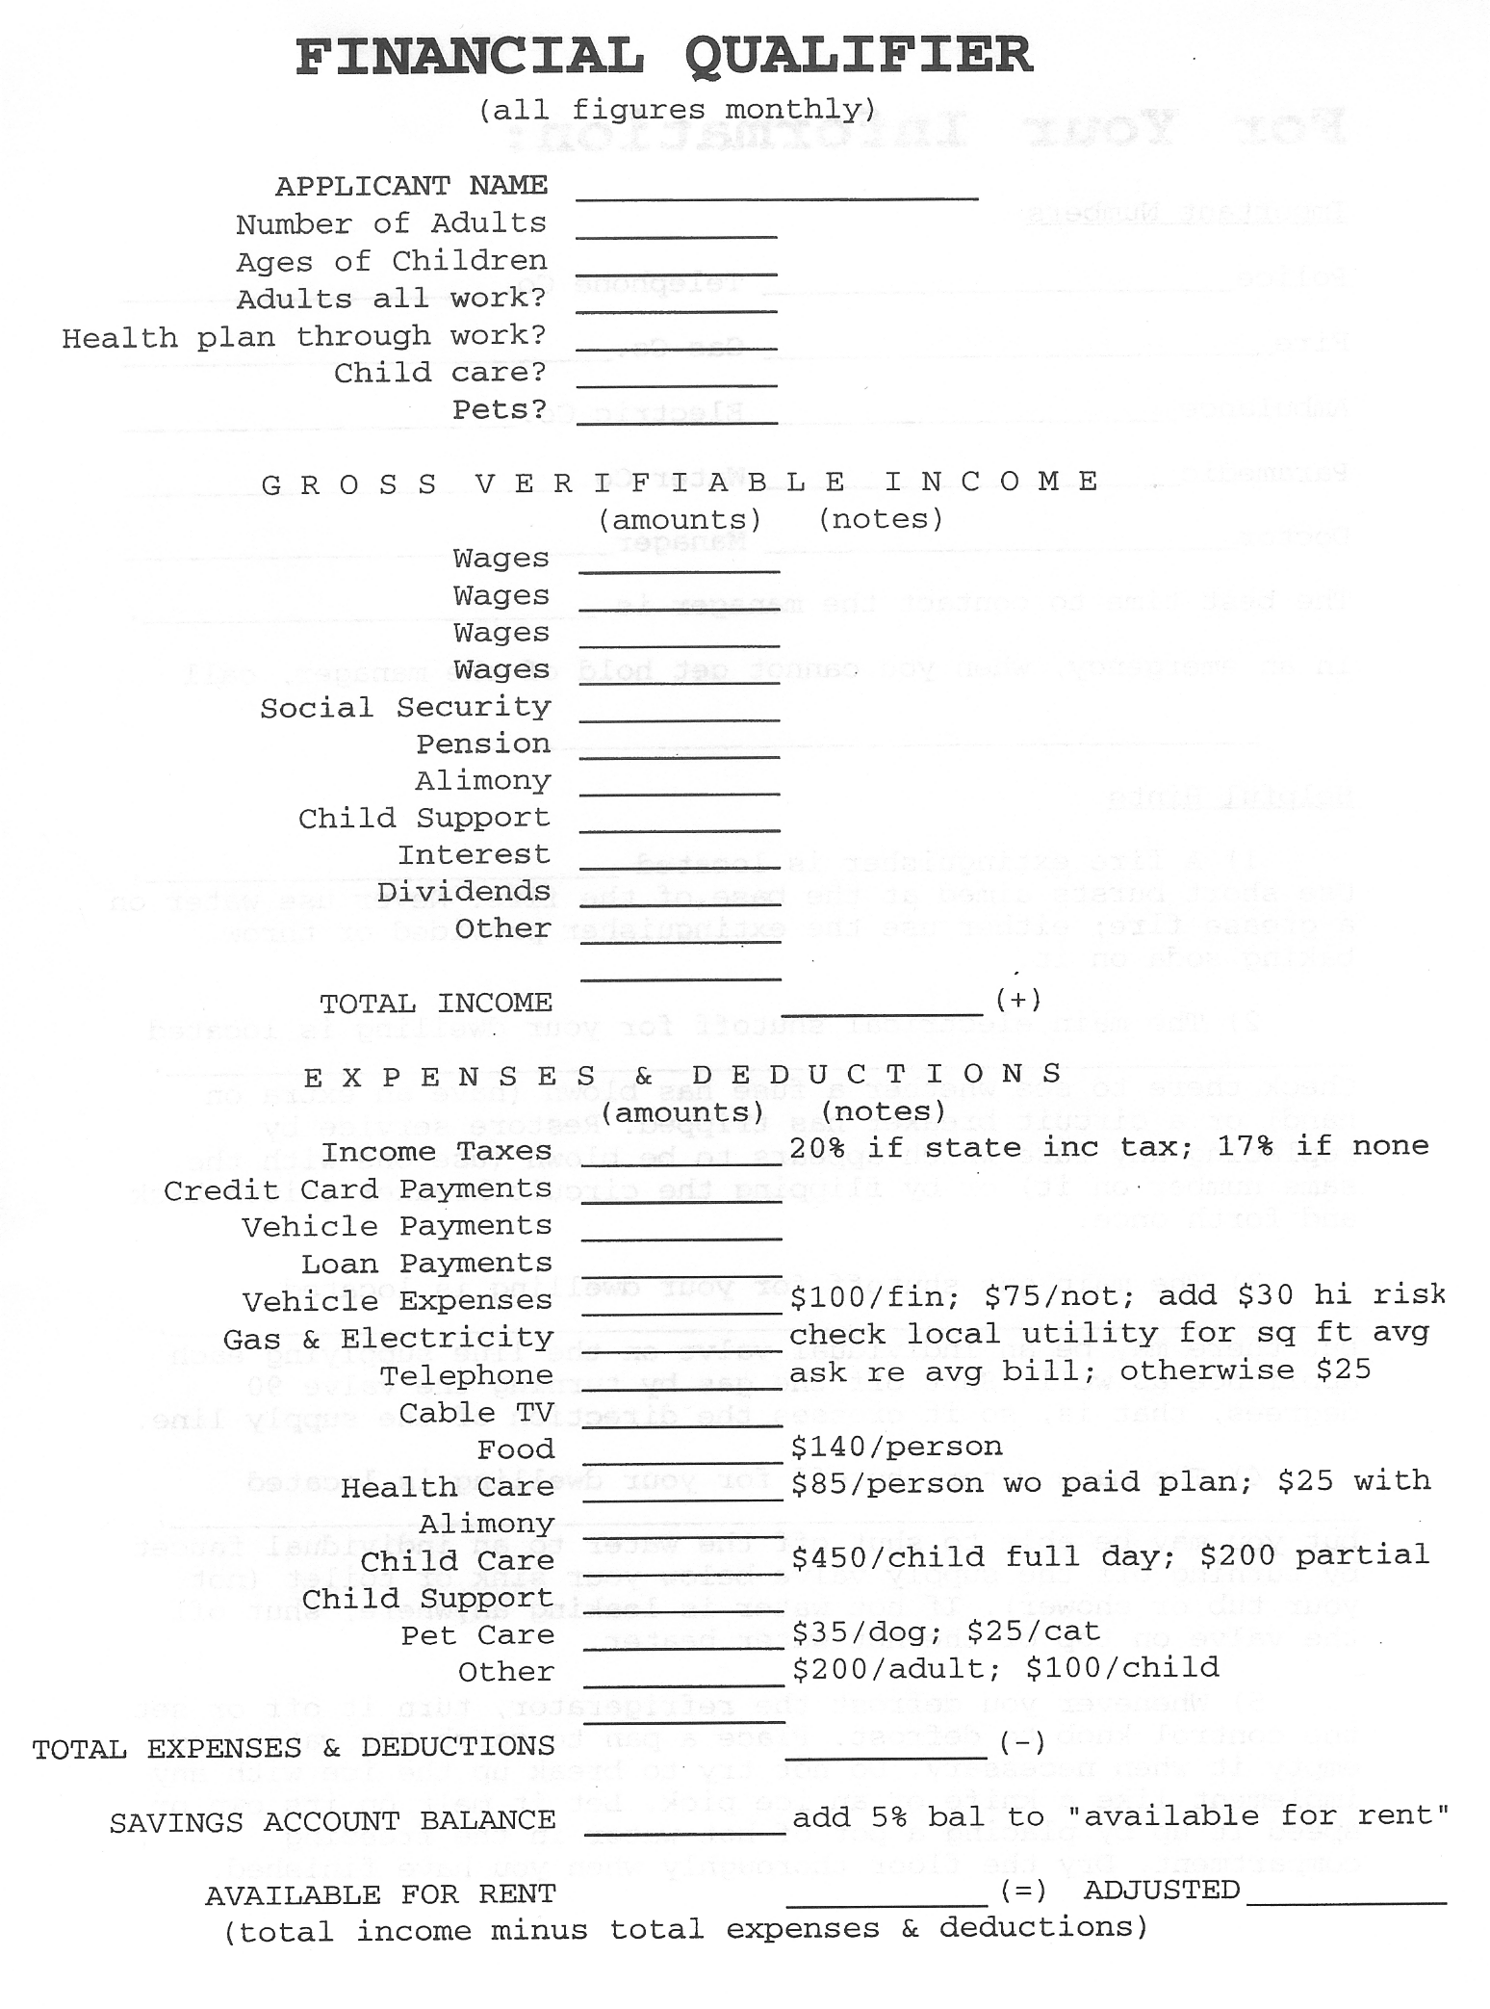
TAK Holdings, Inc.
Page 2 of 8
____________________________________________________________________________________________
This portion for office use only
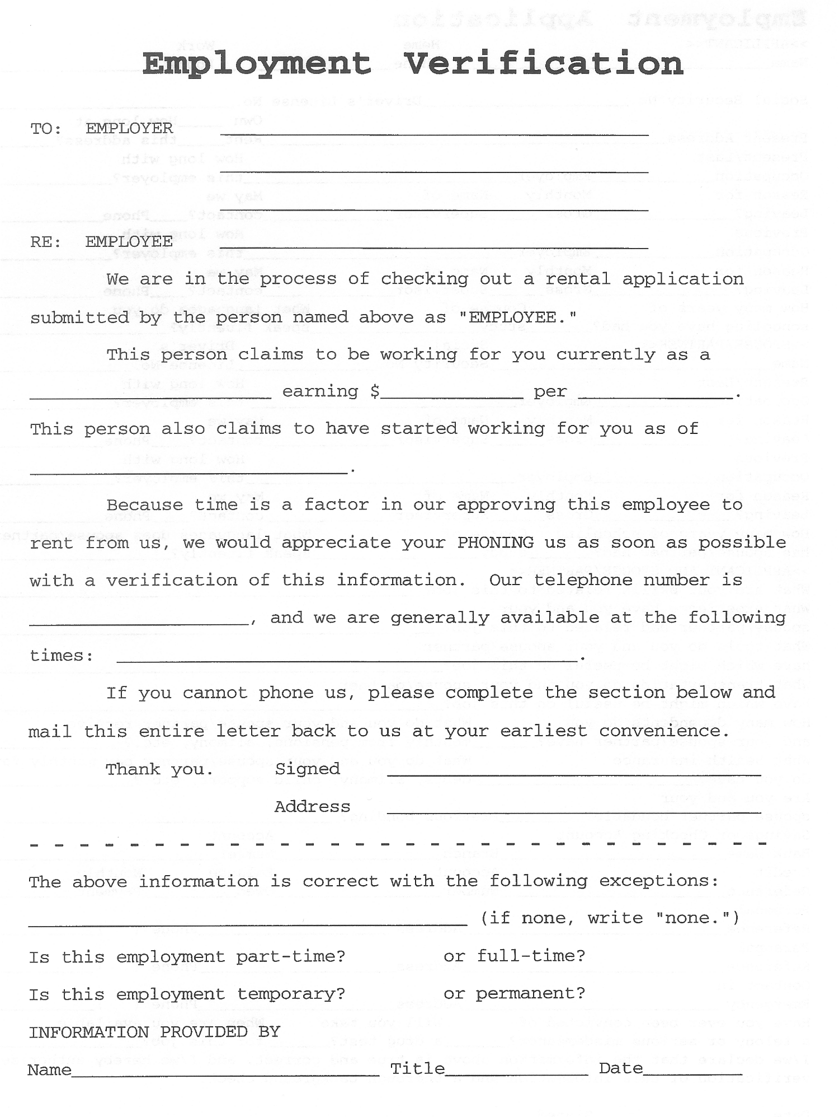
TAK Holdings, Inc.
Page 3 of 8
Street Address
City, State, Zip

X

X

X

X

X

X

X

X
Employer's fax number if available:
_____________________

X
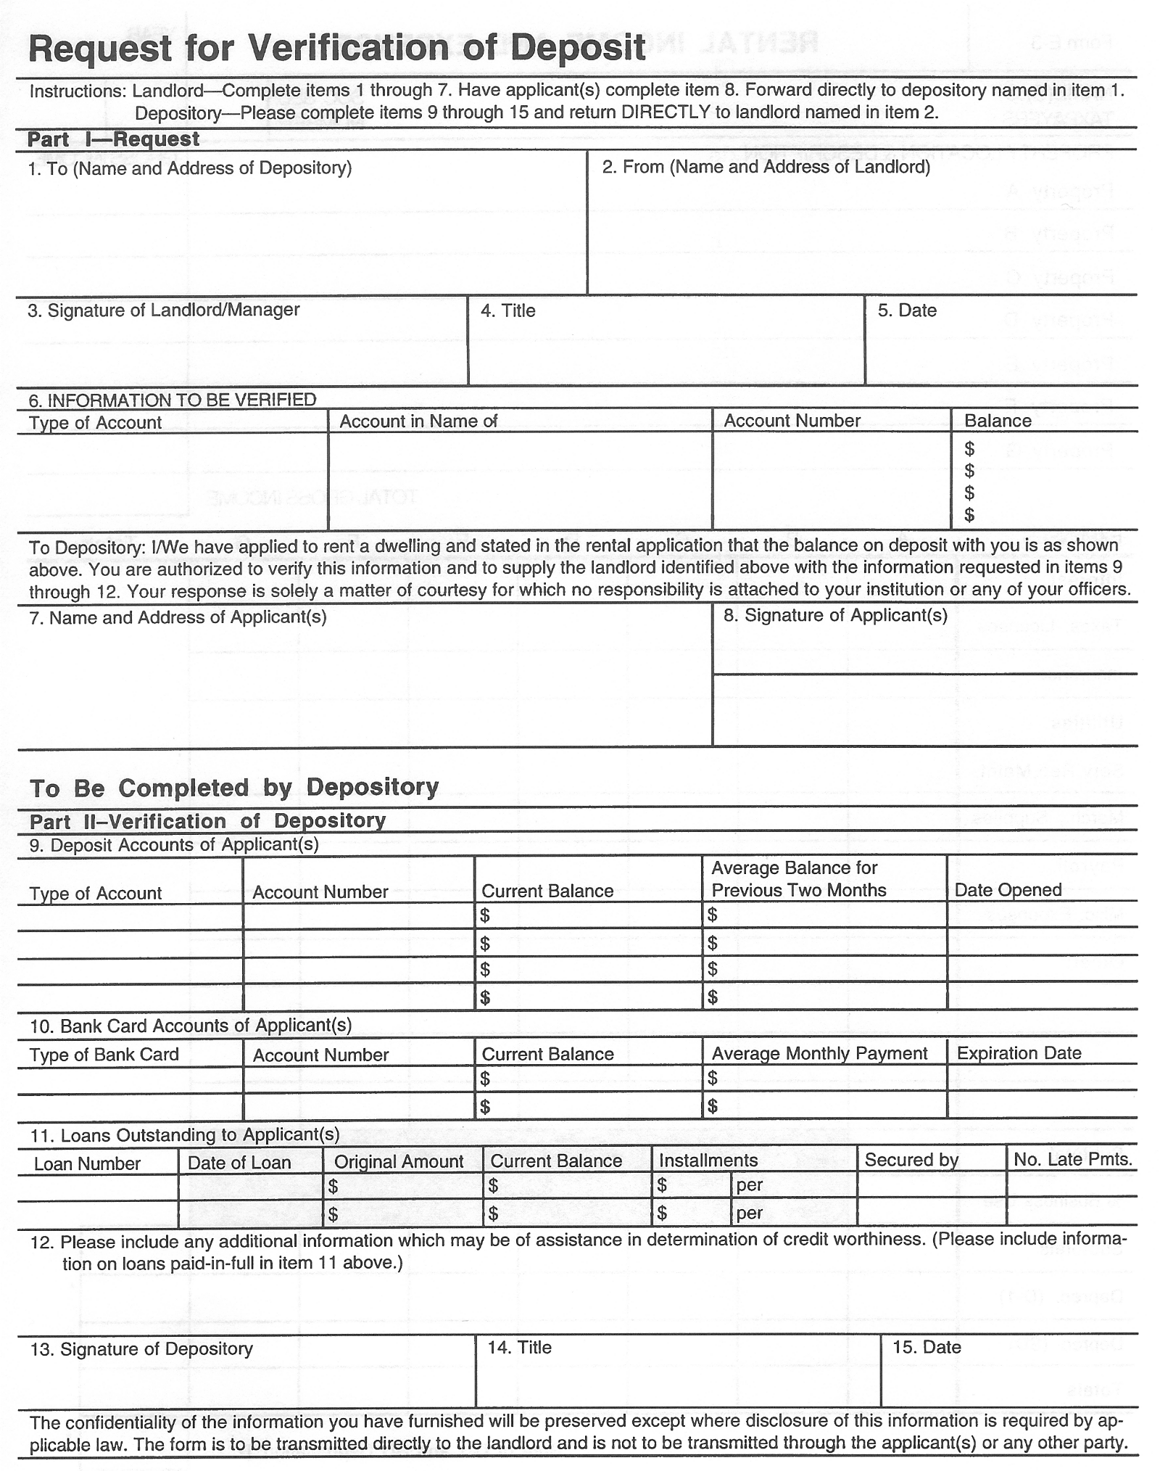
TAK Holdings, Inc.
Page 4 of 8
X

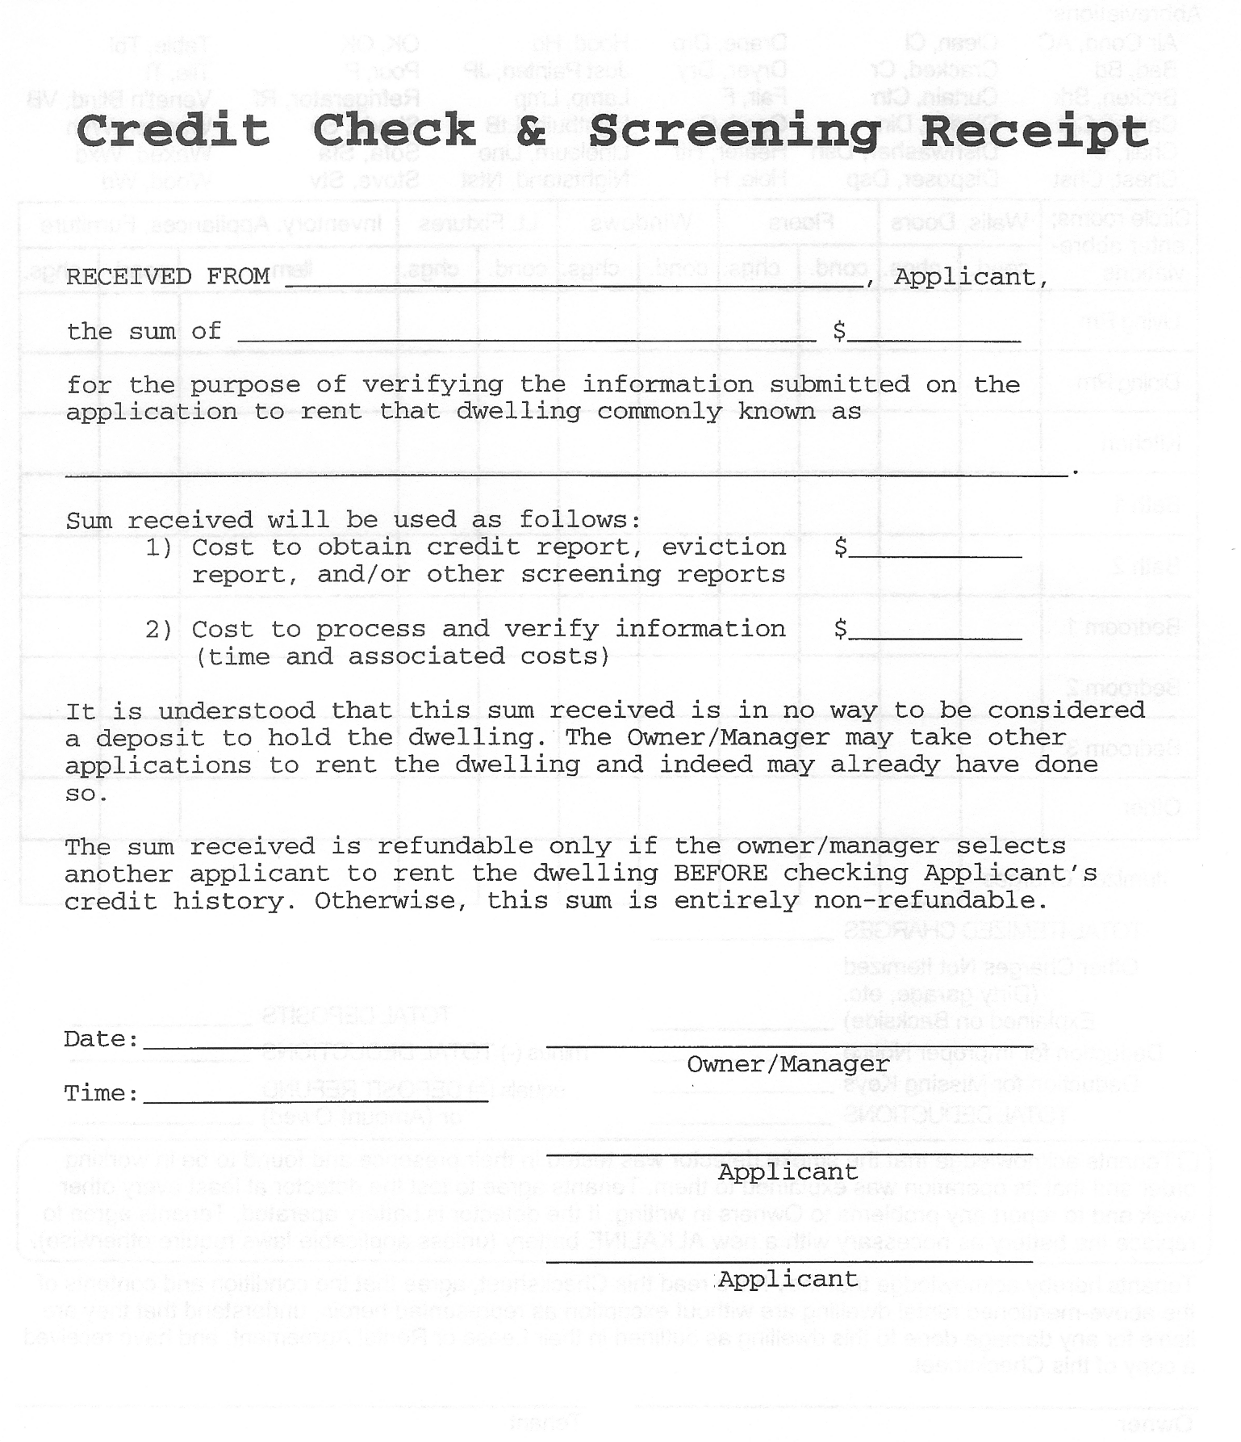
TAK Holdings, Inc.
Page 5 of 8
Applicant Copy

TAK Holdings, Inc.
Page 6 of 8
Owner/Management Copy

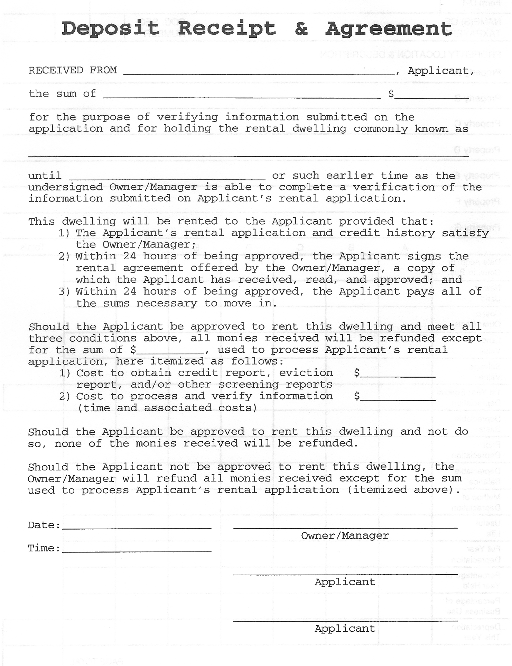
TAK Holdings, Inc.
Page 7 of 8
Applicant Copy

TAK Holdings, Inc.
Page 8 of 8
Owner/Management Copy

