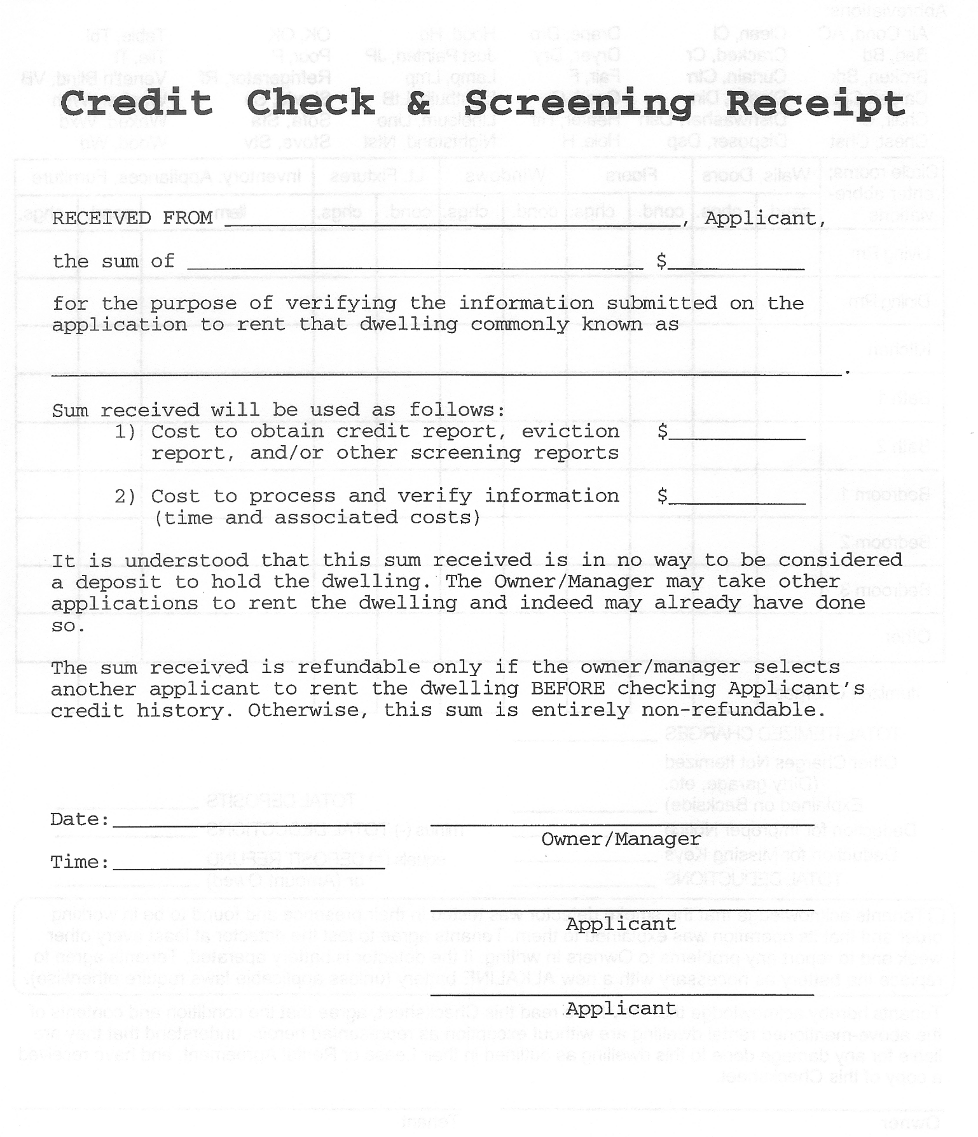
TAK Holdings, Inc.
Page 6 of 8
Owner/Management Copy

