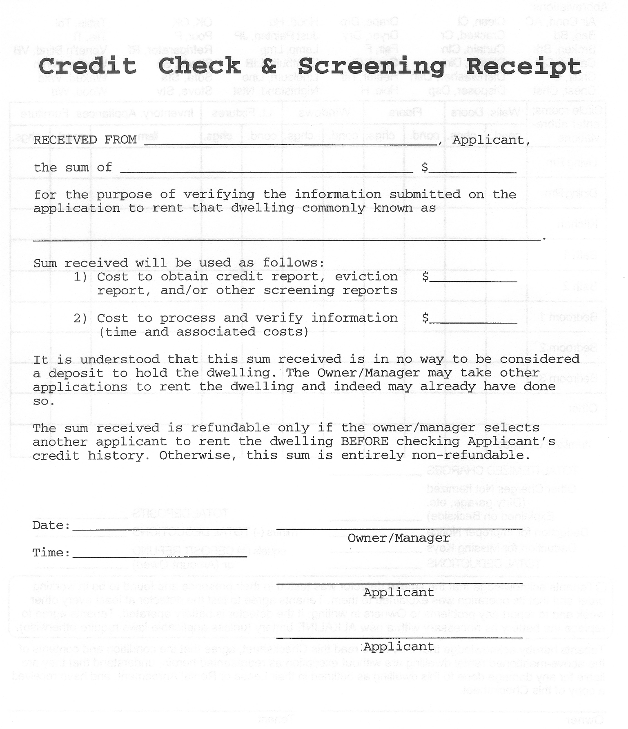
TAK Holdings, Inc.
Page 5 of 8
Applicant Copy

