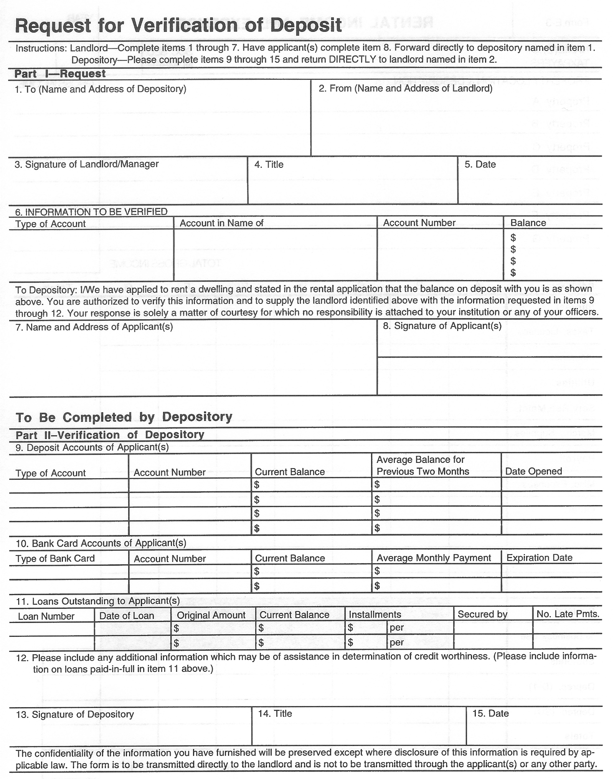
TAK Holdings, Inc.
Page 4 of 8
X

