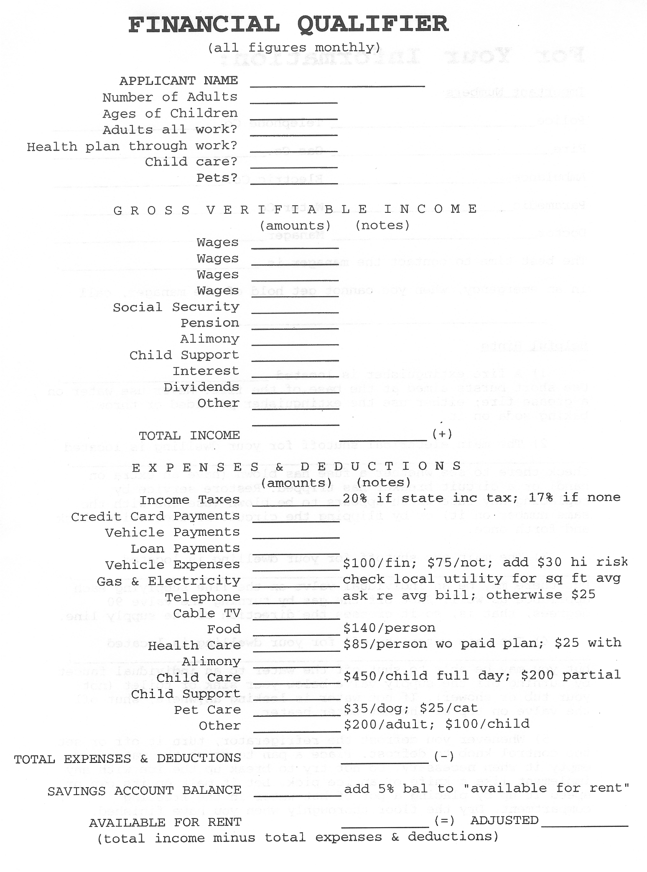
TAK Holdings, Inc.
Page 2 of 8
____________________________________________________________________________________________
This portion for office use only

